TonyBet Ontario Review 2026: Pros, Cons & Features
Affiliate disclosure: OntarioGamers.ca earns commission when you sign up through our links — at no extra cost to you. This does not influence our editorial recommendations.

TonyBet Ontario Casino
Overall rating | 8.6/10
Operator’s legal name | TonyBet Ontario
Parent company | Ligtip Limited
AGCO registration | Active under license no. OPIG1239101
Launch date in Ontario | 2023
Minimum deposit | $10
Minimum withdrawal | $10
Total games count | 2,500+
Major providers | 41+, including Games Global, Big time gaming and Pragmatic Play
Banking methods | Visa, MasterCard, MuchBetter, Interac e-Transfer
Withdrawal time | 12 hours - 7 days
Mobile support | Yes; browser-friendly website, iOS & Android app
Age requirement | 19+
Play Now at TonyBet Ontario
19+ | Ontario Only | Play Responsibly

Overview & Legal Status
TonyBet is among the top online casinos in Ontario and for several good reasons. Much of the operator’s appeal lies in its long-standing reputation, which stretches all the way back to 2003 when it first debuted as Omnibet. In 2009, world famous Australian poker pro and businessman Antanas ‘Tony G’ Guoga acquired Omnibet and rebranded it to TonyBet, the name it carries to date.
In Ontario, Ligtip Limited runs TonyBet Casino and Sportsbook. The company has a valid Alcohol and Gaming Commission of Ontario (AGCO) license and operates under agreement with iGaming Ontario. That means it operates within the province’s legal market with real oversight on disputes, player funds, advertising, and responsible gambling.
While the sports betting section is the brand’s headline feature, a closer look reveals that TonyBet Ontario Casino hosts more than 2,500 high-quality titles. These include 350+ live casino options and 1660+ online slots from 41+ well-known game studios.
Read this TonyBet Ontario review to see how its user interface, games, payouts, support options, and mobile apps stack up against other Ontario online casinos.
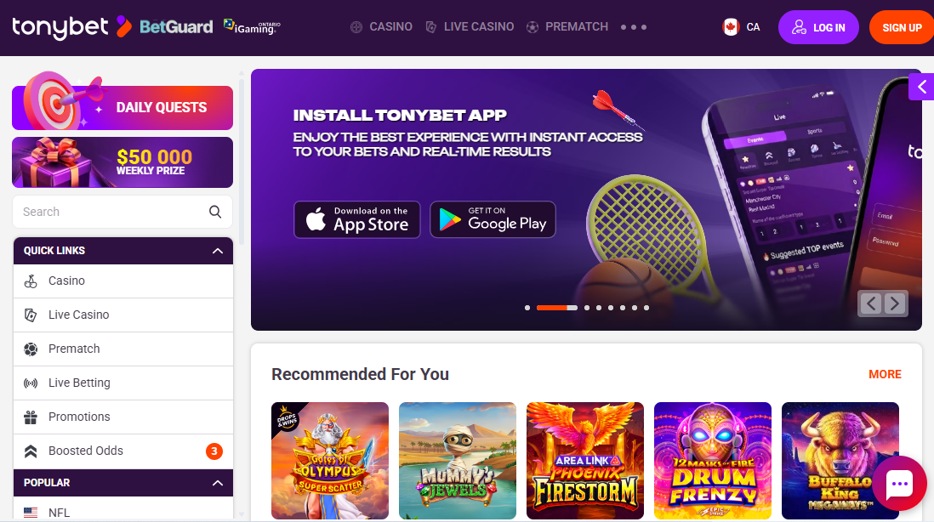

TonyBet Ontario Pros & Cons
Pros | Cons
- Solid reputation across Canada | - No dedicated tab for table games
- Over 2,500 casino games from 41+ major providers | - Offers a small pool of banking methods
- Dedicated iOS & Android apps | - Lacks phone support
- Offers casino games and sports betting under a single account | - Modest app ratings
- Fast Interac deposits and withdrawals

Getting Started at TonyBet Ontario
Opening a TonyBet Ontario casino account involves a three step process, similar to the standard registration flow of a regulated platform. Here’s how to get it done quickly:
Step 1: Click one of our sign up links to head directly to the TonyBet Ontario homepage. Press the orange ‘Sign Up’ button on the top right to access a live registration form.
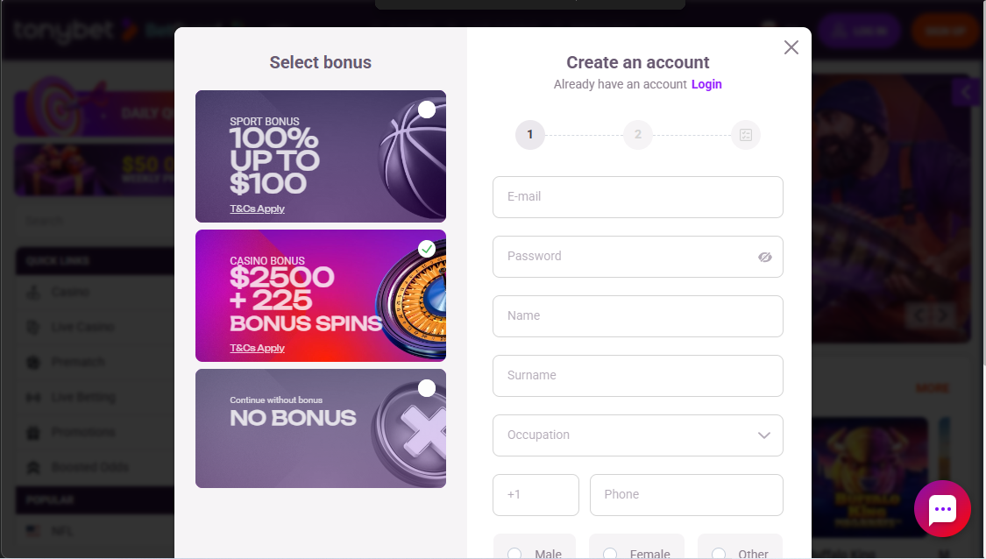
Enter your email, password, full name, occupation, phone number, gender, birthdate, and a TonyBet Ontario promo code.
Step 2: Provide your address
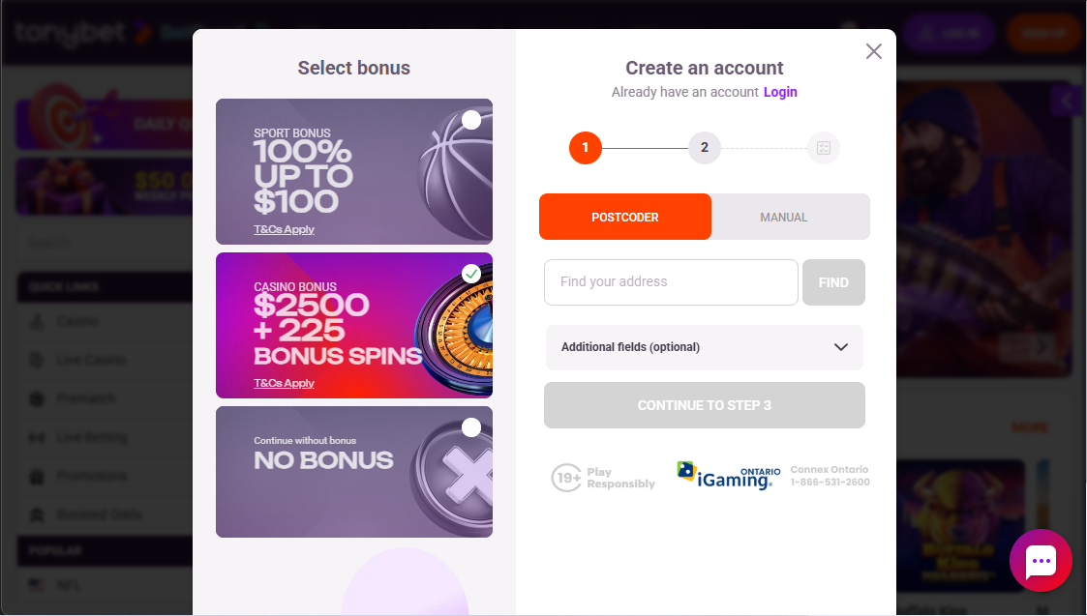
Use postcoder to search for your address or add it manually by filling out the fields. Make sure it is accurate as you’ll have to verify it before requesting your first payout.
Step 3: Agree to the terms & conditions
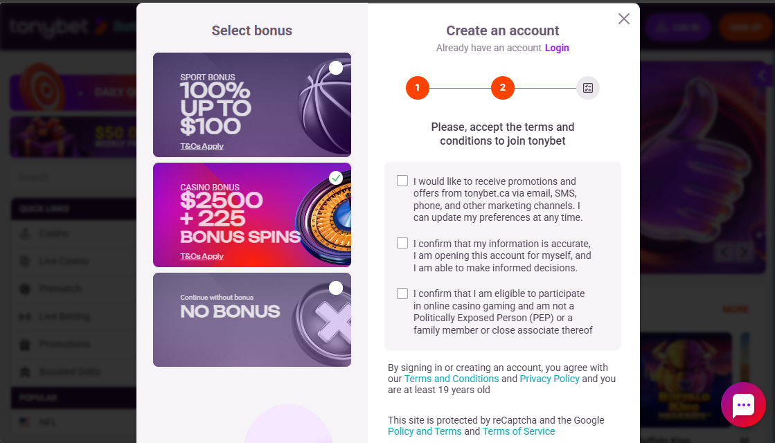
Check the relevant boxes and click ‘Sign up’ at the bottom of the page to finalize registration. You’ll receive a verification email and request to complete identity checks as soon as your first TonyBet Ontario login is successful.

Verifying Your TonyBet Account in Ontario
Ontario gambling laws require all licensed online casinos and sportsbooks to verify player accounts.
TonyBet handles much of this process automatically using the information provided during sign up. If the automatic check doesn’t verify you, you’ll need provide:
- A valid government-issued photo ID (passport, driver’s license, or national ID card)
- A utility bill or bank statement as proof of address
- In some cases, you may need to submit a selfie holding your ID
During testing, sign up and verification was automatic. However, I received a prompt to submit a proof of identity document and a proof of bank account or bank card within seven days of submitting my first cashout request. More details on this in the payments section.

TonyBet Ontario Casino Games
TonyBet Casino has more than 2,500 casino games, powered by around 41 reputable providers. These include Elk Studios, Games Global, NetEnt, and Thunderkick. Compared to our Betway Casino review, TonyBet Ontario’s game library offers more variety, but that’s not the sole reason for our high rating.
The games lobby was simple and well-structured. The homepage is divided into Casino and Live Casino tabs, each with insightful subsections that makes game discovery easy. I did notice the complete absence of a tab dedicated to RNG table games.
Upon further testing, the intuitive search tool helped me find a handful of RNG-based blackjack and roulette options. However, they were not as many as I’ve found at other top Ontario online casinos.

Slots
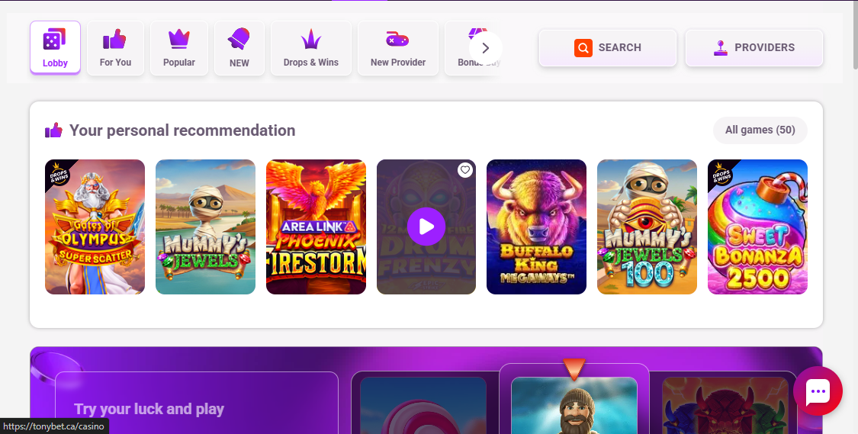
Online slots dominate the TonyBet Casino lobby. During testing, I counted upwards of 1660 options. The selection included a nice mix of classic 3-reel slots, Drops & Wins, bonus buy slots, megaways, hold & win, video slots, and several feature-rich fresh releases straight from the oven.
The variety combined with the steady stream of new titles kept my gaming sessions exciting. I particularly enjoyed the ‘Your Personal Recommendation’ subsections under the Casino tab as it made narrowing down my options easier.
I also found 10+ jackpot slots using the search tool, including Wazdan’s 16 Coins x5000, which I kept coming back to for its sticky symbols and Hold the Jackpot features.

RNG-based Table Games
While classic table games are a staple in many Ontario online casinos, TonyBet Casino drops the ball in this category. There’s no dedicated tables section, and those I could find using the search tool were only a handful of standard options. These included Atlantic City Blackjack Gold Series, American Roulette, and Baccarat.

Live Casino
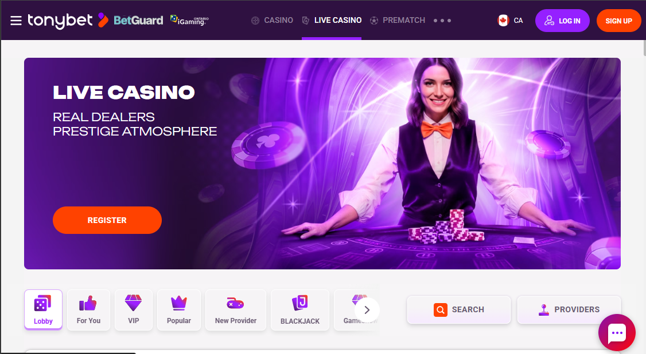
With 350+ options that put you right on the casino floor at Atlantic City, there’s enough variety here to satisfy most live casino enthusiasts. Powered by Evolution and Pragmatic Play, TonyBet’s live casino offers 280+ live blackjack variants, 20+ live gameshows, 35+ live roulette tables, and 45+ live baccarat titles.
I particularly enjoyed the VIP section, where I found a good mix of live games with bets starting from as low as $0.10 and going up to $5,000. On top of that, the HD streams were clear, the tables looked professional, and the dealers regularly interacted with players via the live chat.

TonyBet Ontario User Experience
Landing on TonyBet Ontario, I was immediately met with a simple layout that hosts both online casino games and betting options. And despite a basic online casino and betting interface, moving around was quick and easy.

Desktop Experience
One thing I can say about using TonyBet Ontario on desktop is that it sticks to the basics. When looking at games, payments, support, and account management, nothing seemed overly advanced, which made moving around the site very easy.
The main sections were laid out clearly, and I rarely had to dig around to find what I needed, except when finding specific titles. Compared to our Jackpot City Casino Ontario review where the UX felt more flashy and glamorous, TonyBet’s layout feels familiar with very few extra features that make it stand out.

Browser & Mobile Apps Experience
TonyBet Ontario offers a browser-friendly site for those who prefer not to download extra software. It also offers an iOS and Android app for a more personalized experience. I tested the TonyBet Ontario mobile experience first hand through the browser site and the iOS app.
Navigation was easy as functionality remained identical to the desktop site. That said, the app felt a little slower than on browser and desktop, with the lag particularly noticeable when playing live casino games. Perhaps the reason for the low app ratings of 3.1-stars on the App Store and 3-stars on the Google Play Store. For this reason, I recommend sticking with the browser site.
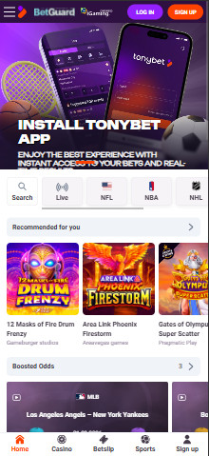

Key Reasons to Try TonyBet Ontario
After spending time on the TonyBet Ontario platform, a few things stood out worth highlighting.
- ‘Your Personal Recommendations’ tab: This tab, present in both the casino and live casino section, offers players a customized, regularly updated list of games to try.
- Boosted odds: TonyBet offers daily boosted odds for select matches across a range of markets, increasing the potential value of winning bets.
- AI analytics:The platform has AI-driven insights that players can use to make smarter bets across specific markets and events.

Banking Options at TonyBet Ontario
Although quite limited, TonyBet Ontario payment options cover the essentials. Plus, the available methods come with zero extra costs for deposits or withdrawals.

Ways to Deposit Funds
Players can fund their TonyBet Ontario accounts using:
- Visa
- MasterCard
- Interac e-Transfer
- MuchBetter
During testing, I used Interac, which has a $10 minimum, the same as other deposit options available on this platform. The funds reflected instantly in my account. But there was a $20 minimum deposit required to activate any payment method.

How to Withdraw Winnings
The same TonyBet deposit options are available for payouts with the same $10 minimum. With such limited options, I had to stick with Interac since I used it for deposits. While the actual withdrawal process was fairly standard, I received a prompt to submit further verification documents.
It took about 4 hours for my account to get approved. After that, I received my first Interac cashout in less than 12 hours. Visa and MasterCard payouts, on the other hand, can take up to 24 hours.

Customer Support
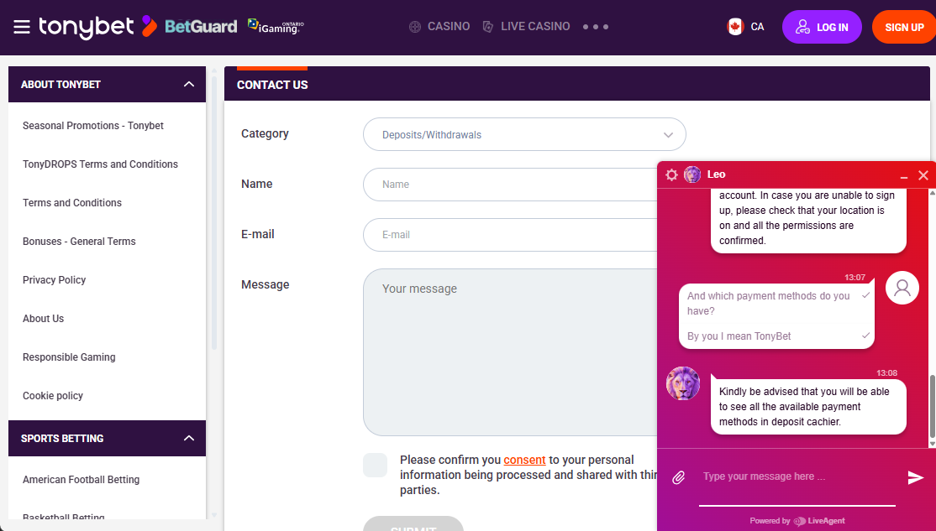
TonyBet offers 24/7 customer support via live chat and email. While no phone support is available, there’s a fairly detailed FAQ section, with categories such as general questions, betting, payments, TonyBet account, bonuses, and cashout.
My experience with TonyBet’s live chat was fairly positive. The support agent immediately entered the live chat, and his responses were professional but a bit vague and deflective, mixed in with a few grammar mistakes.
I also tried email support, accessible via a webform or directly through info@tonybet.ca. The form promises a 24-hr response time which, during my testing, was much shorter (within 18 hours).

Responsible Gambling Tools at TonyBet Ontario
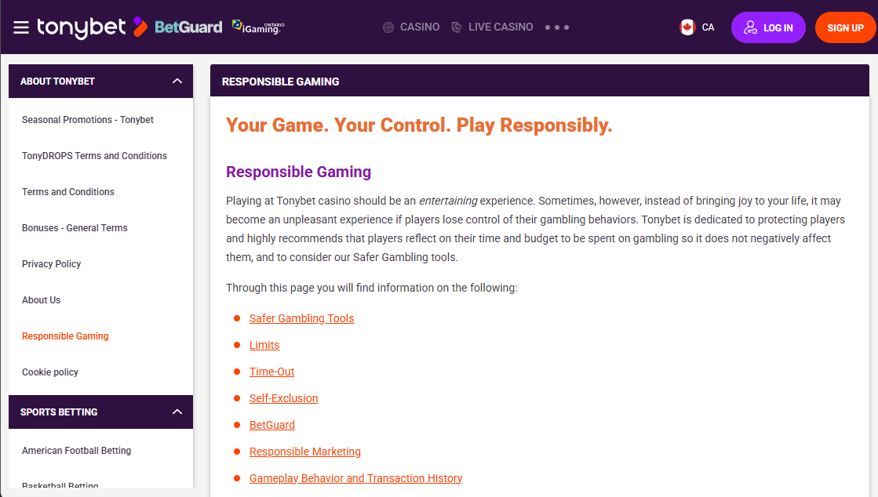
TonyBet supports responsible gambling efforts by covering the core basics you would expect from a regulated Ontario site. During my testing, some of the responsible gambling controls I found under the ‘account settings’ tab included:
- Deposit limits
- Loss limits
- Session reminders
- Time out periods
- Self exclusion options
I also found several self assessment tools and links to various state and national organizations, including ConnexOntario and the Responsible Gambling Council (RGC). Still, TonyBet doesn’t seem to go significantly beyond what Ontario gambling laws require.

My Verdict on TonyBet Ontario
TonyBet Ontario is a well-built platform that earns its place in Ontario’s increasingly crowded regulated market. Although it isn’t one of the more standout operators, what I appreciate is its solid all-round casino and sportsbook experience.
Both the website and app experience are clean. The live casino section holds up well even when things get busy. On top of that, features like the personalized recommendations, boosted odds, and built-in AI analytics add depth to the experience Ontario players will enjoy.
If I had weaknesses to point out, it would be the lack of RNG-based table games, limited payment options, and the deflective live chat interaction.
But after spending considerable time reviewing this operator, I believe TonyBet Ontario is most suitable for players who prefer to keep things simple. The brand reliability and basic functionality makes it a good casino, though not a great one.
If you’re looking for an operator that keeps things working properly rather than adding new or innovative features, TonyBet Ontario is totally worth a look.

TonyBet Ontario FAQs

Is TonyBet legal in Ontario?
Yes. TonyBet is a licensed operator in Ontario. It holds a valid license under the Alcohol and Gaming Commission of Ontario (AGCO) and has signed an agreement with iGaming Ontario. That means it strictly adheres with the province’s standards for fairness, operational transparency, and player safeguards.

Is TonyBet legit?
Yes. Apart from holding an AGCO license, TonyBet Ontario has over 20 years of operational experience across global markets. The site also uses cutting-edge security measures and responsible gambling tools to maintain player safety.

Do I need a separate account for online casino and sports betting?
No. TonyBet Ontario combines its sports wagering and online casino gaming product under a single account wallet. That means players can use the same login and account balance to switch between sports betting and casino games.

How long does TonyBet take to withdraw?
TonyBet withdrawals promise to take between 12 to 48 hours to complete. But it ultimately depends on the payout option used.

Can I use TonyBet Ontario on mobile?
TonyBet Ontario offers an Android and Apple app, downloadable via the respective app stores. However, the app ratings for the apps are very modest, and we recommend using the mobile browser site instead.
Please play responsibly. If you need support, contact ConnexOntario at 1-866-531-2600.

